The Plant Protector

Group 40: David Myers, Beth Kraus

5/4/23, Intro to Embedded Systems ECE 09342 Section 2

**Contribution Chart:**

|  |  |  |
| --- | --- | --- |
|  | David Myers | Beth Kraus |
| Initial Research | X | X |
| Block Diagram and UML | X | X |
| PCB Design | X |  |
| Soldering | X |  |
| Coding |  | X |
| Analyzing Results | X | X |
| Research Related to Project that Helps Report Writing | X | X |
| Writing Report | X | X |
| Making Presentation Slides | X | X |

# **Abstract/Goal:**

Plants are an important part of the environment around us, yet we as humans struggle to care for them. Have you ever gotten a houseplant or a garden plant and two weeks later it's dead? In those two weeks, the plant was undergoing constant changes yet from our view, it did not look like it changed. Then suddenly it's dead. But what if we can chart those changes and receive notifications when the plant needs changes to its environment? For our project, we decided to design an embedded system that will help plant owners take care of their potted plants at home.

# **Background/Introduction:**

The Plant Protector is a system that uses sensors programmed in C and utilizing a custom PCB to give a user feedback about the health of their house plants, and what they should do to take care of it. When the plant’s needs are not being met, an alarm is raised, and a message is sent to the user. While it is difficult to track down the origin of plant care devices like this one, it is safe to say that many variations of them have been developed over time by independent engineers and businesses alike. A device like this takes many shapes and sizes but generally they all serve a similar function, that being to help users keep their plants healthy with minimal attention needed.

# **Methodology and System Design:**

**PCB Design**

1. We were originally going to make a board that functions depending on the MSP430 development board, however we scrapped the idea early on.
2. The next redesign was made to be standalone, with an MSP430 microcontroller soldered onto the PCB itself, removing the need for a dev board. However, used custom dimensions that would have made soldering more difficult.
3. Final revision utilized a given schematic with modifications made so it fit our needs better.

Design Choices for Final PCB Revision

1. Copper Pour on back layer: We utilized a copper pour on our PCB to help reduce heat and complexity of the design. This pour acts as our ground, and greatly reduces the number of traces needed.
2. Using the given schematic: Using the provided schematic to design our PCB off helped greatly with soldering components later in the project as there was no need to worry about custom dimensions. This also guaranteed us a compact design.
3. Independent System: The final design contains a Micro USB header that sends 5V to the system and a 1x4 pin connection for flashing the microcontroller. This allows the system to function on its own without the help of a dev board.

**C Code**

1. We initialized the GPIO pins needed for our board.  See the following list of the pins used and what was connected to them:
   1. Pin 1.7 = RX
   2. Pin 1.6 = TX
   3. Pin 1.5 = Buzzer
   4. Pin 5.0 DHT 11
   5. Pin 5.1 Soil Moisture
2. We started the ADC and set it up to be a 2 channel ADC for the two sensors.
3. We started and setting up the UART
4. UART sends data using the WIFI module
5. We will have an interrupt with the following conditions in it
   1. If the temperature goes below 16 C or above 30 C then the buzzer will go off
   2. If the humidity goes below 30% or above 50%, then the buzzer will go off
   3. If the soil moisture goes below, 20 % or above 40%, then the buzzer will go off

**Major Components**

* DHT11: We chose to use the DHT11 due to its availability and compatibility with C coding. This component acts as our temperature sensor.
* Buzzer: We chose to use a buzzer to inform the plant’s owner that the conditions are not being met.
* Soil Moisture Sensor: We chose this sensor because of its availability.
* ESP8266: We chose to use the smaller form of the ESP8266 because of size and of convenience when coding. This wifi module allows us to send notifications to the user.

## Functional block diagram

## UML Activity Diagram

## Parts List and Design cost

|  |  |  |  |
| --- | --- | --- | --- |
| **Part** | **Quantity** | **Price** | **Source** |
| MicroUSB header | 1 | $1.01 | [1050170001 Molex | Connectors, Interconnects | DigiKey](https://www.digikey.com/en/products/detail/molex/1050170001/2350832?s=N4IgTCBcDaIIwAYCsC4HYC0DtxAXQF8g) |
| 100nF capacitor | 1 | $0.23 | [Rowan ETR | Inventory](https://etr.rowan.edu/inventory/part/1340) |
| 10uF capacitor | 1 | $0.51 | [Rowan ETR | Inventory](https://etr.rowan.edu/inventory/part/470) |
| 1nF capacitor | 1 | $0.35 | [Rowan ETR | Inventory](https://etr.rowan.edu/inventory/part/544) |
| 1uF capacitor | 2 | $0.96 | [Rowan ETR | Inventory](https://etr.rowan.edu/inventory/part/563) |
| 5.1k resistor | 1 | $0.10 | [Rowan ETR | Inventory](https://etr.rowan.edu/inventory/part/89) |
| 47k resistor | 1 | $0.10 | [Rowan ETR | Inventory](https://etr.rowan.edu/inventory/part/112) |
| 1x40 Row Female Headers | 1 | $3.75 | [Rowan ETR | Inventory](https://etr.rowan.edu/inventory/part/843) |
| 1x40 Row Male Headers | 1 | $0.33 | [Rowan ETR | Inventory](https://etr.rowan.edu/inventory/part/1592) |
| Temperature/Humidity Sensor | 1 | $5.66 | [DHT11 UNIVERSAL-SOLDER Electronics Ltd | Sensors, Transducers | DigiKey Marketplace](https://www.digikey.com/en/products/detail/universal-solder-electronics-ltd/DHT11/16822119) |
| Soil Moisture Sensor | 1 | $8.68 | [Rowan ETR | Inventory](https://etr.rowan.edu/inventory/part/1891) |
| Wifi Module | 1 | $7.50 | [Rowan ETR | Inventory](https://etr.rowan.edu/inventory/part/1515) |
| PCB | 1 | $5 | NA |
| Microcontroller | 1 | $3 | NA |
| Buzzer | 1 | $2.99 | [Amazon.com: Fielect 2Pcs 100dB Buzzer Alarm Electronic Beep Buzzer DC 3-24V SFM-27 Active Piezo Buzzer Continuous Sounder Electronic Buzzer Alarm Black : Electronics](https://www.amazon.com/Fielect-Electronic-Continuous-Piezoelectric-Sensitivity/dp/B0838Z8LTS/ref=sr_1_3?crid=NG8DZSN02IES&keywords=sfm-27%2BBUZZER&qid=1682361555&s=industrial&sprefix=sfm-27%2Bbuzzer%2Cindustrial%2C68&sr=1-3&th=1) |
|  | Total Cost | $40.17 |  |

# **Experimental Set Up and Results:**

## Schematic:

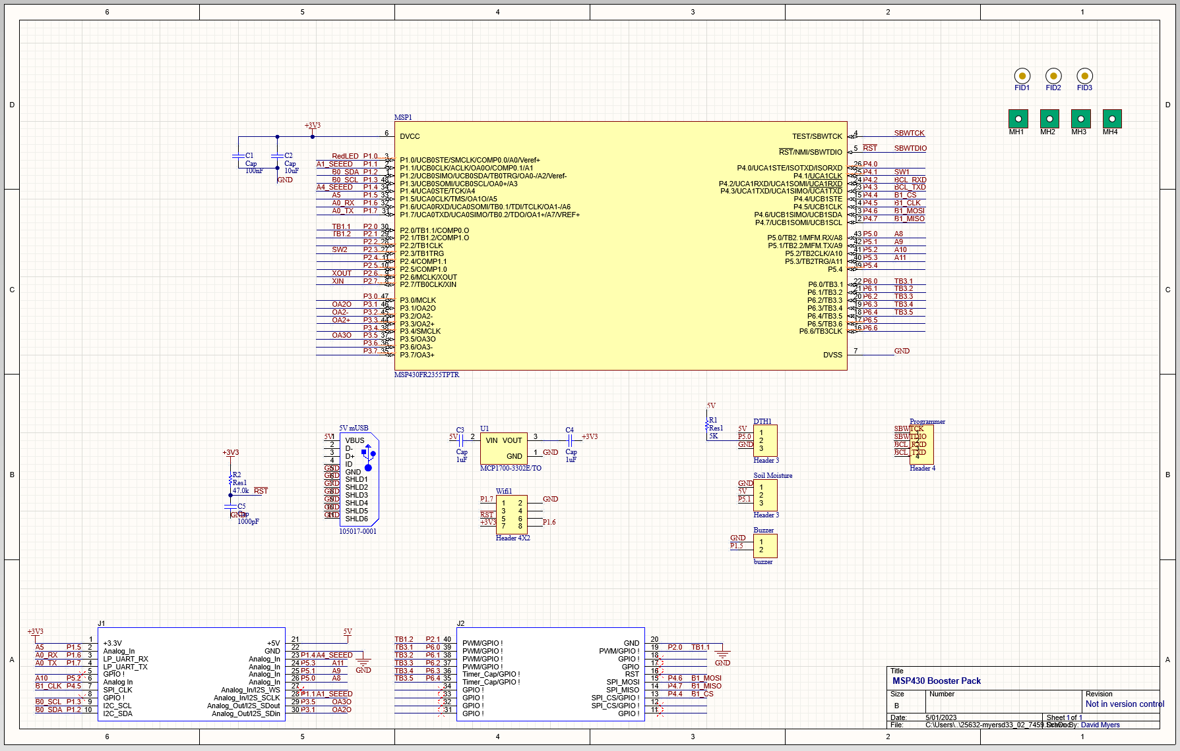

## Soldered PCB connection with MSP430:

## Results from ThingSpeak

Unfortunately, we did not have time to finish the wi-fi configuration for our project. If it did work, it would have sent us an alert notifying us of the problem the plant is facing.

# **Conclusion/Future Work**

In conclusion, we designed and built a simple proof of concept idea that helps a user maintain plant health by reading plant vitals through sensors and relaying that information back to the user via wi-fi and actuation all utilizing C programming. We gained experience on the entire engineering design process, along with various other skills. We learned about troubleshooting C code and PCB design along with a deeper understanding of the software we were instructed to use. Going forward, we would like to make a more robust design with more features. Given our lack of experience in some areas and time limitations, we had to cut several design choices we planned originally. Some features such as humidity reading, and automated watering capabilities were removed because of this. In the future, we would love to incorporate these features and several others to make a more complex device that could be applied to not just house plants, but much larger areas such as farms or greenhouses.

# **References**

*Acta Horticulturae*. www.actahort.org/members/showpdf?booknrarnr=881_111.

Ag, Advancing Eco. “About.” *Advancing Eco Ag*, www.advancingecoag.com/pages/about.

# **Appendix**

[b-kraus/The-Plant-Proctector: To defend those plants in need (github.com)](https://github.com/b-kraus/The-Plant-Proctector)